Animation Loop

---------------------------------------------------------------------------------------------------------

**Team Members:**

1. Mayank Raghuwanshi
2. Vedant Bhamare
3. Suchit Deshmukh
4. Aditya Ramakrishnan

**Project Guide:** Dhruv Suvarna ma’am.

---------------------------------------------------------------------------------------------------------

**Introduction:**

We have created an Animation loop of two pendulums swinging through a rotating hoop.

---------------------------------------------------------------------------------------------------------

**About Our Project:**

In this project we have created looping animation using Blender.

We created two spherical balls for pendulum with a rod attached to them. These plane of swinging motion of these pendulums are perpendicular to each other. Then we created the hoop structure through which the pendulums would pass. We removed a bit of top part of the hoop for the rod to pass though.

After that we focused on the surroundings and environment of the animation. We have used and HDRI environment to get perfect exposure and outdoor lighting condition.

Then we added 2 planes, one for the reflective water surface in which ripples would be formed. These ripples will be formed using the second plane which we used a particle emitter, of which the emitted particles will the reflecting plane to created ripples in it.

To create the plane below reflective we created a glossy material on it, and for the ripples we use the physics tab and used dynamic paint on it. The sky reflection in that plane is of the HDRI environment we used earlier. As for the other plane we use particle emission, we also used a transparent material on it so that it’s reflection would not show up in the first plane as it is directly above the first plane.

Then we added texture to the spheres and hoop. We gave hoop a custom-made texture using different nodes. And for spheres applied premade textures to the hoop using a similar method as for the hoop.

Then finally we set up the position for the camera and started rendering the whole animation.

**Final project:**

We have linked the final rendered animation below: <https://drive.google.com/file/d/1jPRpT6QI-ZeRnPO9Nmp_zaaldiDoDGPo/view>

**Screenshots:**

* This is the look of our project in solid preview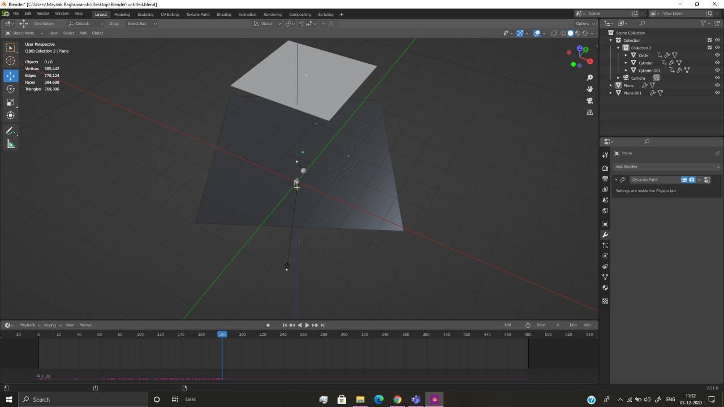
* This is the look of our project in material preview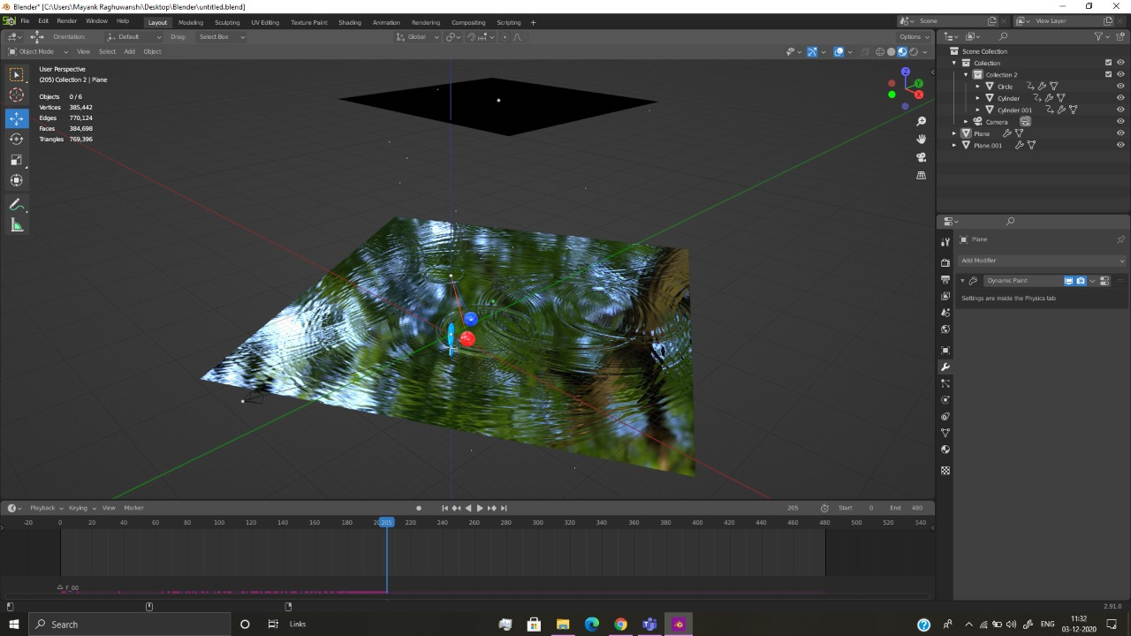
* These are the screenshot of our project in render preview-

The above one is with HDRI transparency enabled and the below one has it disabled.

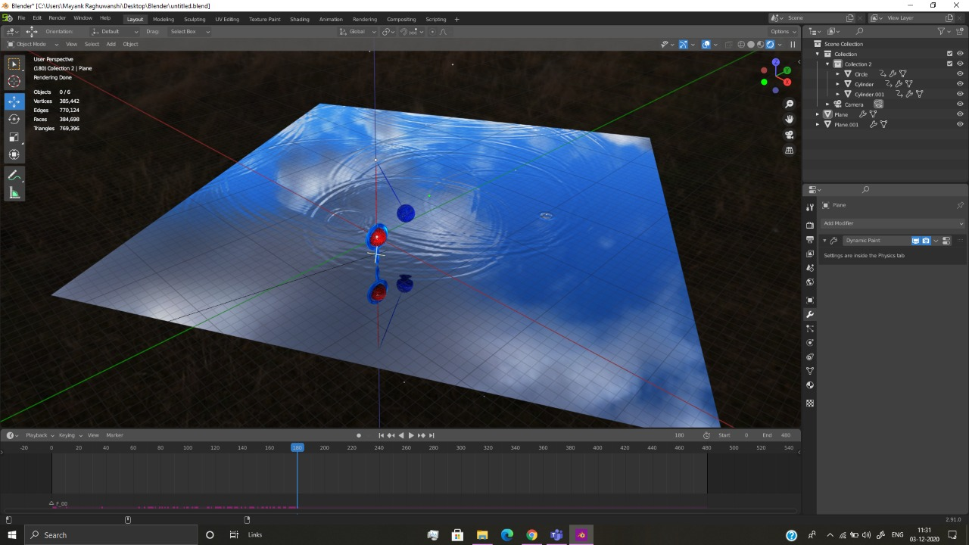

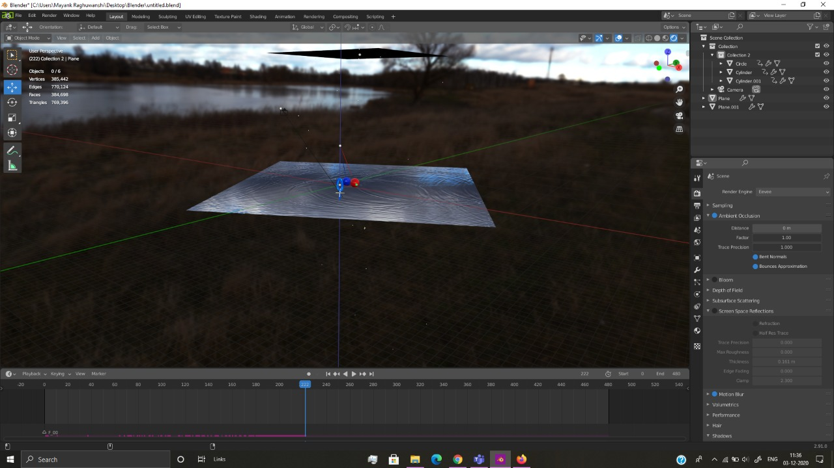

* These are the screenshot of our project of creating animation movement for the objects-

The above one is spheres and the below one is for the hoop.

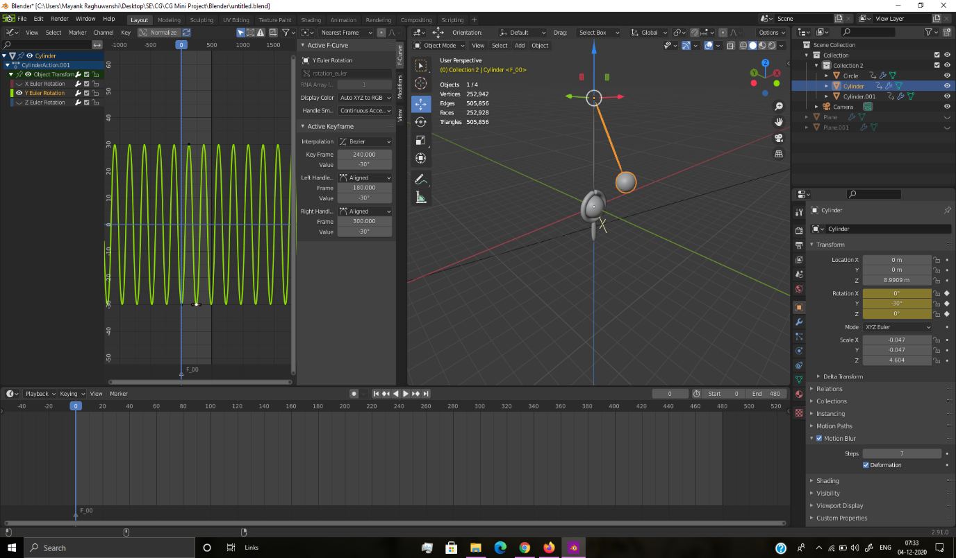

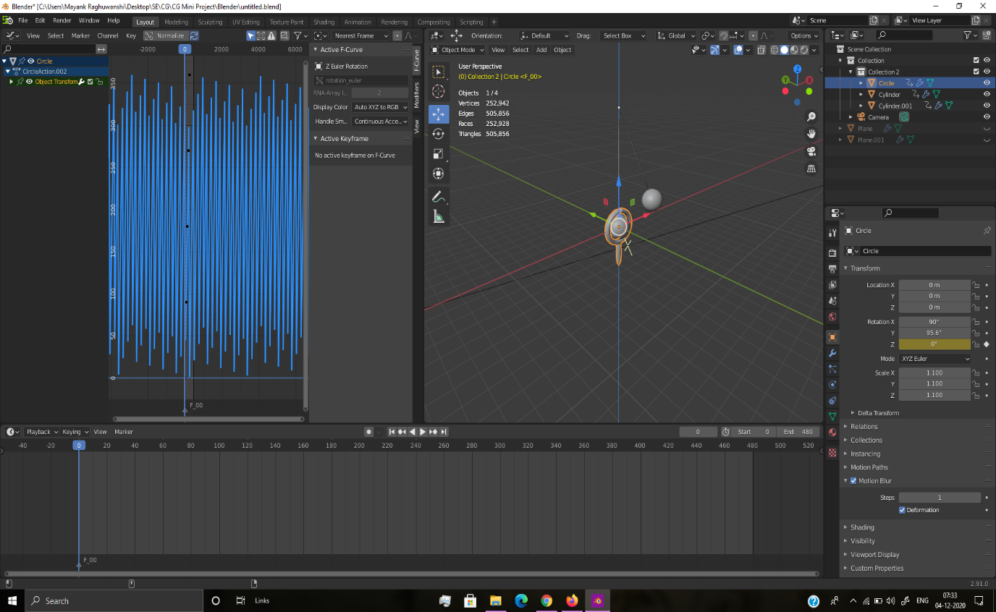

* These are the screenshot of our project of creating texture look for the objects-

The above one is hoop (custom texture) and the below one is for the spheres (pre-made textures).

